Label

TextBox

CheckBox

Panel

Button

Radio Button

Property: StartPosition - for show the form in the center

FromBorderStyle - out line border remove

PasswordChar - To hide password use any symbol - property of checkbox

UserSystemPasswordChat for password hide

Dock - used to set the Panel tool box . property of panel

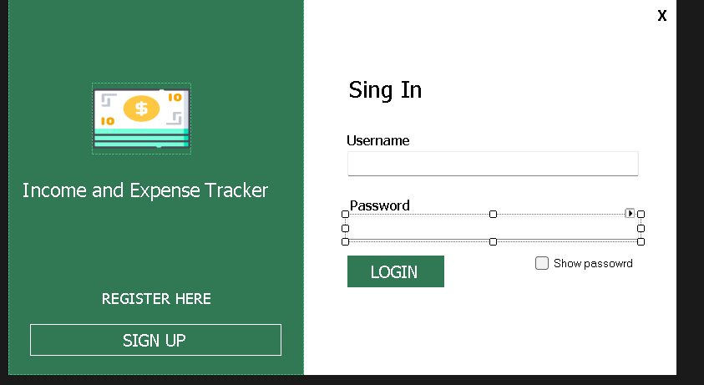

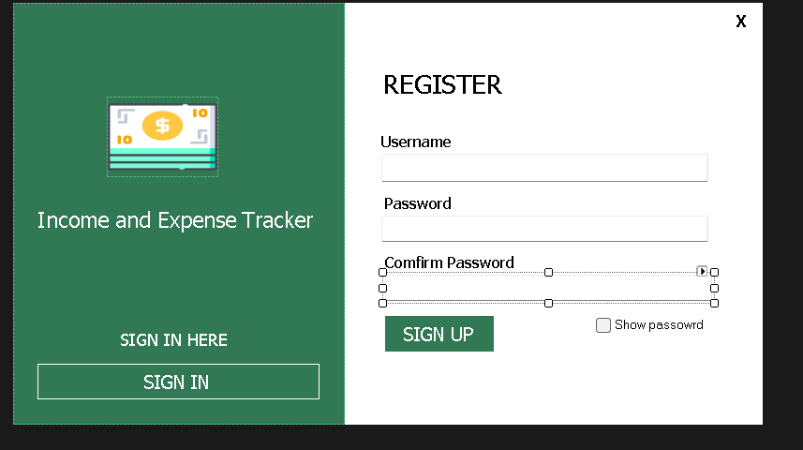

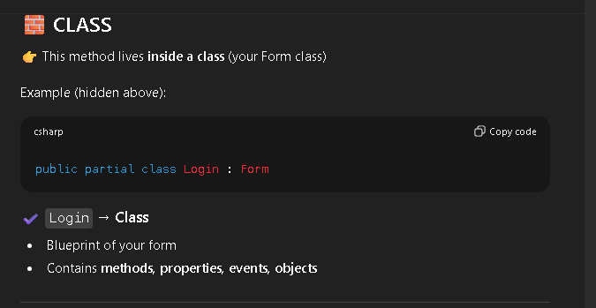

Go one From to another form

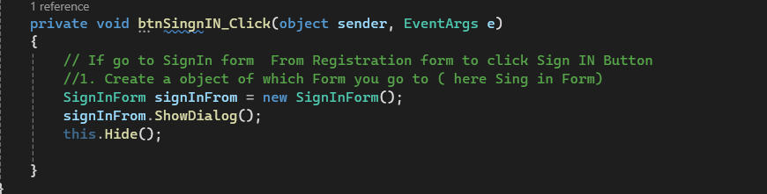

Go back to previous form

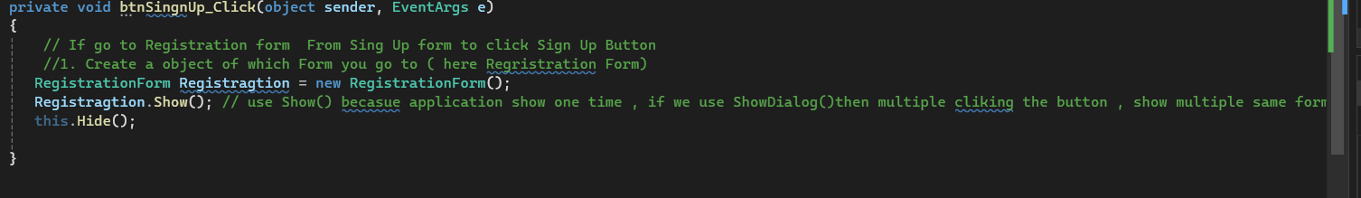

Close a application

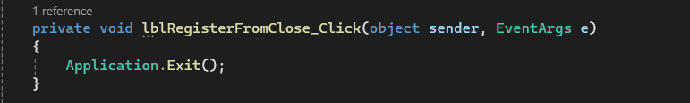

Hide the password code.

| **Code Part** | **Category** |
| --- | --- |
| Login | Class |
| chkSignInShowPassword_CheckedChanged | Method |
| sender, e | Parameters |
| chkSignInShowPassword | Object |
| txtSignInPassword | Object |
| Checked | Property |
| UseSystemPasswordChar | Property |
| CheckedChanged | Event |
| if–else | Control structure |

📌Properties **store values** (true/false here)

